For IJME

**Should life-saving medical data be discarded because it was obtained unethically? Eduard Pernkopf’s atlas as a case in point.**

Sunil K. Pandya[1]

Introduction

I recently came across an excellent anatomical work. Entitled *Atlas of topographical and applied human anatomy*, it was originally published in German and later translated into English. It had taken the author and his colleagues over twenty years to produce it. The atlas, in four volumes, was received with uniform acclaim in Europe and America and praised for its accuracy and quality of illustrations.

A recent study compared its utility with that of Dr. Frank Netter’s atlas. (The first volume of Netter’s *Atlas of human anatomy* was published in 1989. The current, 7th edition, was published in 2018.) ‘The respondents (nerve surgeons) found Pernkopf ’s atlas having both greater anatomical detail (range 79%-91%) and greater utility for surgery (range 66%- 82%) when compared with Netter’s (P < .001) in all plate comparisons.’ (Yee et al 2019)

Internationally renowned and respected neurosurgeon, Dr. M. Gazi Yasargil – not given to handing out praise lightly – said of this atlas, ‘Pernkopf’s work, in particular *Topographische Anatomie des Menschen*, Vol. 4 (800 pages, 218 figures) is of fantastic quality and is appreciated worldwide.’ (Yasargil 2004)

Surgeons continue to use it to plan their operations (Baker 2019). A recent example is its use in the treatment of 13-year-old Israeli schoolboy, Dvir Musai. (Kershner 2020)

Why, I wondered, is this atlas not better known and used universally?

The answer lies in the life and work of the author.

This essay discusses the pros and cons of the rationality of not using data and publications that are accurate and likely to help in treating patients and, in some cases, saving lives merely because they were based on information obtained unethically.

Eduard Pernkopf



Eduard Pernkopf

From CODEX 99 - *under a Creative Commons*[CC BY-NC-SA 4.0](https://creativecommons.org/licenses/by-nc-sa/4.0/)*license.*

Eduard Pernkopf (1888-1955) was born in a small village in lower Austria. His father was a country doctor. He received his medical degree from the Vienna Medical School in 1912 and taught anatomy thereafter. He succeeded his teacher, Ferdinand Hochstetter (1861-1954) as director of the Second Anatomy Institute in Vienna from 1933 onwards.

The Viennese Anatomy Institute had been divided into two departments in 1870. Anatomy 1 was clinically oriented and was led by Jewish scientists. The chairmen of Anatomy 2 tended towards nationalism and anti-semitism. During the 1920s and 1930s there was much antagonism between students from the two departments. In 1938 Anatomy 1 and 2 were reunited under the chairmanship of Pernkopf.

Pernkopf was described as an obsessive worker and demanding supervisor. He developed his dissection and illustration techniques using skilled artists quite early in his career. His personal routine of 18-hour work days was, in his later years, focused completely on the atlas (Hildebrandt 2006).

Pernkopf joined the National Socialist German Workers, or Nazi Party in 1933. He joined the Storm Troopers, or Brown Shirts, a year later. One month after Nazi Germany invaded Austria in 1938, Pernkopf was made dean of the medical faculty in Vienna. From 1943 to 1945, he was *Rektor Magnificus* (president) of the University of Vienna.

From 1938 onwards, he was highly placed in the hierarchy of the Nazi party in Vienna. His speeches endorsed the Nazi emphasis on eliminating the unfit and defective from the population. Under his dispensation, all professors were required to swear an oath of loyalty to Hitler. (Hubbard 2001)

By the end of World War II, 38,000 doctors in Germany were members of the Nazi party and more than 7% of all physicians were members of the SS. Serving the Nazi party advanced their academic careers, enabling them to carry out research and experiments and to write theses. (Silver 2003)

Pernkopf’s deemed function under the Nazi regime was to lead the country to better *state and racial health*. The doctor was to be a servant of the nation and his greatest responsibility was not to the health of the individual patient but to the health of the state.

Bruns and Chelouche (2017) point out that a brand of medical ethics was very much a part of the medical curriculum under the Nazi regime (1939-1945). ‘The appointed lecturers were mostly early members of the Nazi Party and imparted Nazi political and moral values in their teaching. These values included the unequal worth of human beings, the moral imperative of preserving a pure Aryan people… and the priority of public health over individual-patient care.’

The end of world War 2 resulted in several reverses for Pernkopf. He was dismissed as head of the Institute of Anatomy on 10 May 1945. (Hubbard 2001) In August that year he and his artist Bathke were arrested by the American military. He was never charged with war crimes but was sentenced to hard labour for 3 years in an American prison camp for war criminals near Salzburg. He continued to work on his atlas during imprisonment. On his release, Dr. Hans Hoff, a Jewish physician and Director of the Institute of Neurology in Vienna, allotted him two rooms for his work.

The atlas was all he had left and all that kept him alive. Once again, he brought together his artists. In 1952 he published the section entitled *Der hals* (The neck).

Pernkopf’s student and post-war successor as Director of the Second Anatomy Institute – Hermann von Hayek – praised Pernkopf’s love of music. He referred to his composition of an unpublished symphonic drama and called him a great teacher, researcher and human being. (Hildebrandt 2006)

Pernkopf died on 17 April 1955 from a haemorrhagic stroke whilst working on the fourth volume of his book. The last two volumes were brought out by Werner Platzer, regarded by many as his scientific son. ‘Despite Pernkopf 's long fall from grace, his burial turns out the entire faculty. He is celebrated by fellow professors as a perfectionist, a stirring teacher and the impresario of what many increasingly regard as the world's greatest anatomy book.’ (Paterniti 2002)

The Pernkopf Atlas

The first edition of volume 1 was published in 1937. Currently available volumes of the atlas are of the 2nd and subsequent revised editions. (Pernkopf 1980)

Paterniti (2002) provides graphic descriptions of the creation of this atlas and of Pernkopf’s work on it.

Needing a dissection guide for his anatomy students, Pernkopf started out with the creation of a laboratory manual. Studying other anatomy texts, he found them outdated or unsatisfactory. He upscaled his project to provide the definitive atlas on human anatomy. This *magnum opus*, in four volumes, took him over twenty years of eighteen-hour workdays. It contained 800 paintings by eleven carefully selected artists. The technique of four colour separation was refined for his purpose.

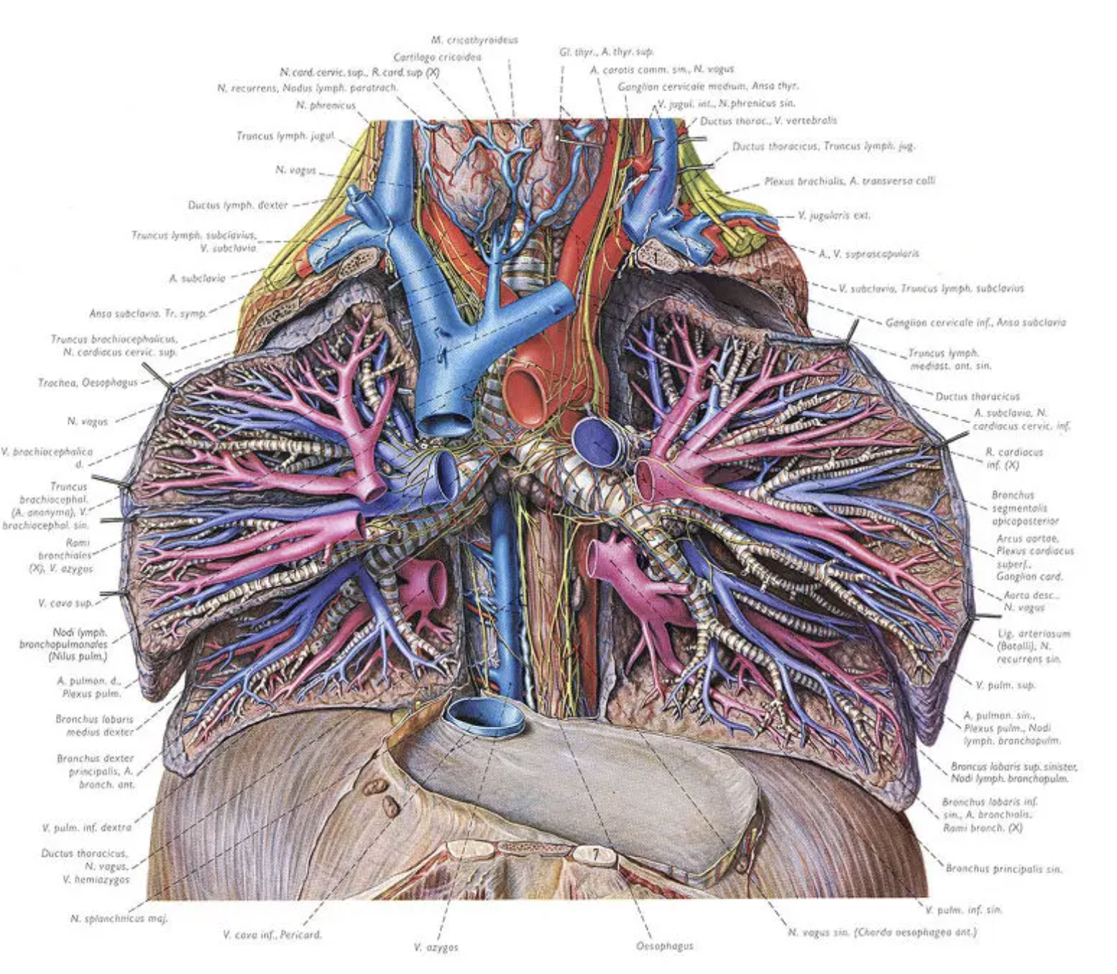

Detailed illustration of the dissected lower neck and chest from Pernkopf’s atlas. From CODEX 99 - *under a Creative Commons*[CC BY-NC-SA 4.0](https://creativecommons.org/licenses/by-nc-sa/4.0/)*license.*

Pernkopf wrote the text by hand. His wife typed it out. Assisting Pernkopf were the best graphic designers and artists in Vienna, among them Erich Leper, Ludwig Schrott, Karl and Frank Intresser Bathke. About half of the original illustrations in the anatomical atlas were not created during the Nazi years. Some were made before 1937 and others after 1945. The dates of creation as well as the source of the bodies used as models for 350 paintings is unclear (Hildebrandt 2006).

When dissections were performed for the illustrations to be included in the book, Pernkopf was ‘driven by ideas of accuracy and clarity’. His publishers, Urban & Schwarzenberg, shared his dedication and vision.

‘He comes to care about only two things: the Book and the Party.’ (Paterniti 2002)

Paterniti also tells us of David Williams’ search for Franz Bathke – the last of Pernkopf’s artists. On meeting him, Williams wrote in his journal, ‘I am truly beginning to see this man as a genius.’ After studying art under Bathke and reviewing Pernkopf’s atlas, Williams praised it as ‘the standard by which all other illustrated anatomic works will be measured.’ Paterniti too appears to have been enthralled by the work. ‘The book is blindingly beautiful, an exaltation, a paean and a eulogy all at once. Page after page, the human body unfolds itself, and with each page the invisible becomes visible, some deeper secret reveals itself.’

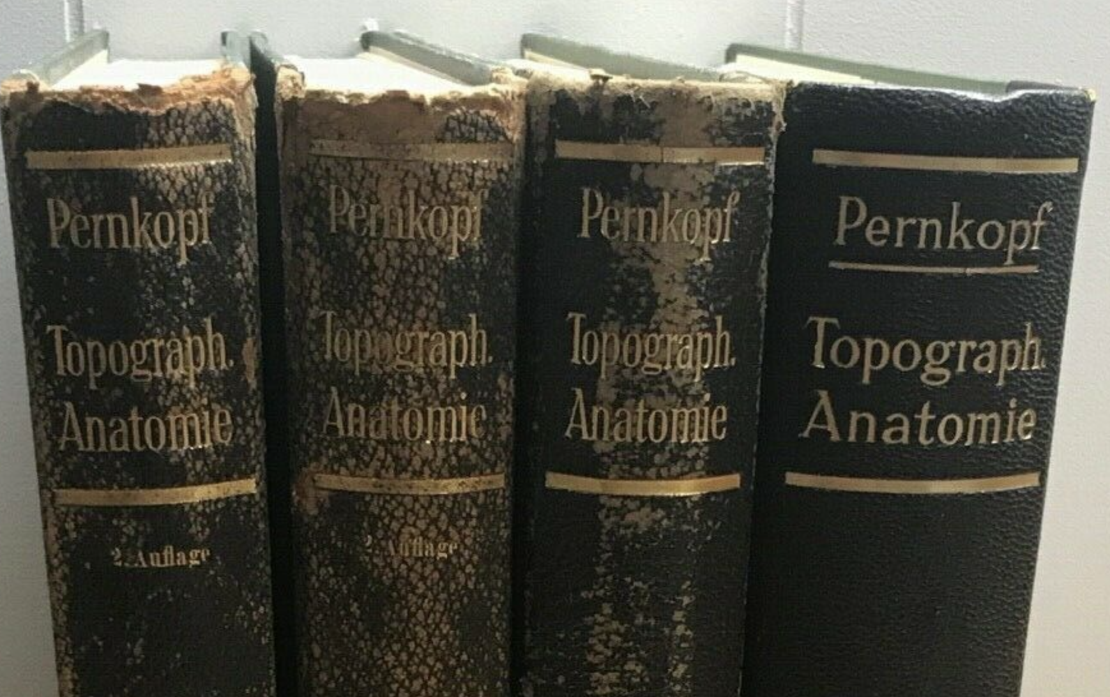

Volumes from the 1941 edition as depicted in a sales catalogue.

‘So who is Pernkopf? If he's taciturn with his painters, it is because he maintains the utmost professionalism. A dreamer, an intellect, a lover of music, he is in the workshop early in the morning and late at night: He is simply an overwhelming presence. The Book becomes both his great unwritten symphony and, slowly, his madness. (Paterniti 2002)

The supply of corpses for dissection in Vienna

Michael Atlas (2001) provides details on the controversy regarding Pernkopf and his anatomical atlas.

‘The piece that really sparked the current controversy about the Pernkopf atlas was a letter to the editor of *JAMA* in November 1996 signed by a professor of dental surgery from Columbia University and a professor of family and community medicine from the University of Toronto… Most pointedly they said that the precise origins of the cadavers used in Pernkopf’s work are unknown, but evidence suggested they may have been victims of political terror. It is known that the Anatomy Institute of the University of Vienna received the cadavers of prisoners executed at the Vienna District Court and of others put to death at Gestapo execution chambers in Linz, Munich, and Prague.’ (Atlas 2001)

In 1998, the Jewish Holocaust Remembrance Authority requested an enquiry by the University of Vienna and that Pernkopf’s history and a commemoration of the Nazi victims be included in future editions of the atlas.

‘The final report of the Pernkopf Commission of the Faculty Senate of the University of Vienna was issued on 1 October 1998. The investigation revealed that the Institute of Anatomy received at least 1,377 bodies of executed persons, including 8 victims of Jewish origin… On the basis of a general decree of February 18th, 1939, the bodies of persons executed were assigned to the Department of Anatomy of the nearest university for the purposes of research and teaching… No proof could be found that bodies had been brought to the Vienna Department of Anatomy from the Mauthausen (concentration) camp complex… The presumption and suspicions that some of the illustrations might be of prisoners of war or Jewish victims are based predominantly on impressions which strike the critical observer. In these cases, however, the investigation was able neither to prove nor to disprove the suspicions. Because of the systematic practice of making specimens anonymous, it seems likely that a final clarification of such suspicions will not now be possible.’ (Atlas 2001)

It is relevant to study how bodies had been acquired earlier for dissection in Vienna. Buklijas (2008) provides an excellent historical review.

Vienna was the site of the earliest recorded anatomical dissection outside the Mediterranean, preceding cities in today’s Germany and Switzerland by almost a century. Unclaimed bodies and those of executed criminals, those committing suicide and of duelists were used for this purpose. In Vienna, anatomies were performed first sporadically and from 1537 annually by a faculty member in the Allgemeine Krankenhaus – Vienna’s large teaching hospital – and in the presence of medical students, doctors, apothecaries, surgeons, and learned men from the faculty of arts.

The bodies of executed criminals and paupers formed the bulk of the corpses used for anatomical and pathological studies up to the 19th century. Around 1850, the Allgemeine Krankenhaus was itself supplying 2000 corpses annually to the medical faculty. (The mortality rate in the hospital was 13.4% in the 1850s.) Joseph II, Maria Theresa’s son and heir, had founded this hospital in 1784. The hospital accommodated thousands of sick poor. Joseph decreed that the use of the bodies of these patients for medical education was a fair repayment for the free medical care they had received in the hospital.

These corpses were treated with respect. ‘St. Joseph of Arimathaea organized and paid for the burial of dissected cadavers from the anatomical institute in wooden coffins. Between 1857 and its dissolution in 1917, the Arimathaea became such an integral part of anatomy that anatomical cadavers became known as Arimathaealeichen [Arimathaea corpses].’ This overcame the objection of the Roman Catholic church regarding the ultimate fate of the bodies. (Buklijas 2008)

Nineteenth-century Vienna was renowned for its medical facilities. High standards of education and research, easy access to corpses for anatomical and pathological studies and to patients with a variety of diseases attracted students from all over the Western world.

For religious and political reasons, Jewish bodies were kept out of the reach of anatomists. Up to the 1920’s few Jewish bodies were subjected to dissection.

Pringle (2010) provides details on the procedure under Nazi dispensation. From 1938, anatomists at the University of Vienna made arrangements with local Nazi officials to receive the bodies of prisoners shot in the Gestapo rifle range or guillotined in Vienna’s assize court building. If the medical school morgue was full, court officials postponed the executions. (Hildebrandt 2006)

‘Eduard Pernkopf’s anatomical atlas, celebrated for its art but notorious for using the cadavers of victims of the fascist regime in the 1930s and 1940s, was the last in a tradition that went back to the nineteenth century.’ (Pringle 2010)

Whilst working with Bathke, one of Pernkopf’s artists, Williams asked whether death-camp cadavers were used in the book, the old man became enraged and denied it vehemently. Simon Wiesenthal examined the records and his conclusions confirmed Bathke’s statement. (Paterniti 2002)

Arguments pro and con banning the atlas

Paterniti (2002) and Michael Atlas (2001) summarise these well.

Scott Norton, Chief of Dermatology at Water Reed Institute of Research (2001a,b) was placed in a dilemma when he found two volumes of Pernkopf’s atlas in his department.

Norton referred to two book reviews. The first was in the *New England Journal of Medicine* (1990): ‘The publication of this third edition of the Pernkopf Anatomy testifies to the success that this classic atlas has met with among anatomists throughout the world… This outstanding book should be of great value to anatomists and surgeons. It is in a class of its own and will continue to be valued as a reference work.’ The second was in the *Journal of the American Medical Association* (1990): ‘The majority of the illustrations in this atlas are truly works of art, demonstrating by their clarity and precision the best in collaboration between master medical artists and skillful anatomic prosectors.’

Norton noted that outside the University of Vienna, the story of Pernkopf and his atlas was largely unknown until the mid 1990s, when several reports led to investigations of the university’s wartime practices.

Norton went about his task systematically. He collected background information on the atlas, distributed it to all members of his department and, after they had studied it, held a meeting. In the text circulated he pointed out, ‘Just as Andreas Vesalius’s *De humani corporis fabrica* and *Gray’s Anatomy* blur the line between science and art, *Pernkopf’s Anatomy* maps the human body in exquisite detail that has won praise from generations of medical illustrators.’ He did not hold back information on Pernkopf’s Nazi activities and the sources of bodies for anatomical dissections. He quoted Helmut Gruber (then the Viennese school’s deputy dean) that it was 99% certain that Pernkopf’s atlas did NOT contain any drawings of Jews or other victims of concentration camps. He also quoted Richard Panush who had stated in a letter to the *Journal of the American Medical Association* in 1996: ‘(We) decided to expunge it (the atlas) from our collection… I believe that our moral obligation to society, to victims and survivors of Nazism, and to posterity is to repudiate Pernkopf and all that he represented…’

He then asked his colleagues whether it was acceptable for them to use the atlas.

The consensus reached by the department was that the atlas should not be retained in the department library as it was irrevocably tainted and the information in it was not unique. The volumes were therefore transferred to the special collection in Walter Reed’s main library because of its place in medical education and ethics. Library users were to be permitted to use it as ‘fully expunging the book hearkens to Nazi-era book burnings.’

Norton commented that this consensus ‘inserted an uncomfortable moral relativism. After all, anatomists historically have obtained their models from the gallows and graveyard. Would Pernkopf’s atlas be less tainted if the cadavers were from executed hardened criminals, say, child murderers, rather than those whose crimes were political?’ He also posed another question, ‘Can a scientific or an artistic achievement be separated from the manner by which it was attained?’

Bagatur (2018) explains the rationale for the condemnation by the medical community of any use of knowledge derived from Nazi biomedical research. The use of such data corrupts the institution of medicine itself. He referred to the disfavor with which such eponyms as Reiter’s syndrome, Hallervorden-Spatz syndrome and Asperger’s disease are viewed today because of the Nazi associations of the persons after whom they are named.

Many of those who lost family members and friends in the Nazi concentration camps could not see the atlas as repository of anatomical accuracy and beauty. For them, ‘the Book is nothing but a dirty crime scene, violated bodies that might include her brethren. The artists are no better than vultures over their carrion.’ (Paterniti 2002)

Some, like Abraham Foxman, national director of the Anti-Defamation League, said that the research findings of heinous crimes or atrocities should not be used, even if it would do good, because it would retrospectively cleanse the atrocity and possibly justify similar acts in the future.

Kenneth Mellanby, then reader in medical entomology at the London School of Hygiene and Tropical Medicine, was appointed *BMJ*s first ever foreign correspondent to cover the Nuremberg medical trials. (He was awarded the OBE for his work on the scabies mite – which kept thousands of soldiers in hospitals. He also helped found Nigeria’s first university at Ibadan and was its first principal. His uncle, Edward Mellanby, was secretary of the Medical Research Council in Britain.)

Mellanby had induced and studied scabies on conscientious objectors who had volunteered to be human guinea pigs. His attitude to the victims of Nazi medical crimes was, ‘the victims were dead; if their sufferings could in any way add to medical knowledge and help others, surely this would be something they themselves would have preferred.’ (Weindling 1996)

The accuracy and superlative quality of illustrations in Pernkopf’s atlas have been lauded by all reviewers.

Atlas himself and others believe that the use of the atlas itself is the most fitting tribute to those who died for it. ‘It is ironic retribution for the Jewish cadavers (or whoever died for whatever beliefs) to be used to illustrate a Nazi’s anatomic atlas and be immortalized by it. Using this atlas allows these cadavers to speak to us from half a century ago. They make us reexamine and again repudiate the Nazi beliefs that created a society that killed them.’

Edward B. Hutton, Jr., as president of Waverly, Inc., was the American publisher of the atlas. The stand taken by him is of interest. In a November 1996 letter to *JAMA*, Hutton said his company continued to publish the Pernkopf atlas because of its scientific merit and because, to date, no concrete evidence had been found to substantiate Pernkopf’s use of cadavers originating from Nazi concentration camp victims. Hutton acknowledged that Pernkopf was an avowed Nazi and, that while Hutton and his company renounced Pernkopf’s abhorrent views, they ‘separate Pernkopf, the man, from the work because of the lack of evidence as to the true origin of the cadavers used in the atlas.’ (Atlas 2001)

Garrett Riggs (1998) echoed the feelings of many when he said, ‘Just as I can in no way condone the beliefs of Pernkopf and his Nazi cronies, neither can I deny the beauty, grace and precision of the images they produced.’

Howard Israel (1998) presented arguments, supported by many, that if some benefit could be derived from the use of the atlas today, to save a life or enable a surgeon to perform more skillfully, its use would honor those who suffered and sacrificed their lives. Such an argument might also maintain that not using tainted knowledge when it might help make better medical decisions might be actually unethical. Israel noted that there was no indication to the unsuspecting user that the book had any link to Nazi medicine, and he viewed suppression of the work as inappropriate and reminiscent of the book burnings that took place in Nazi Germany.

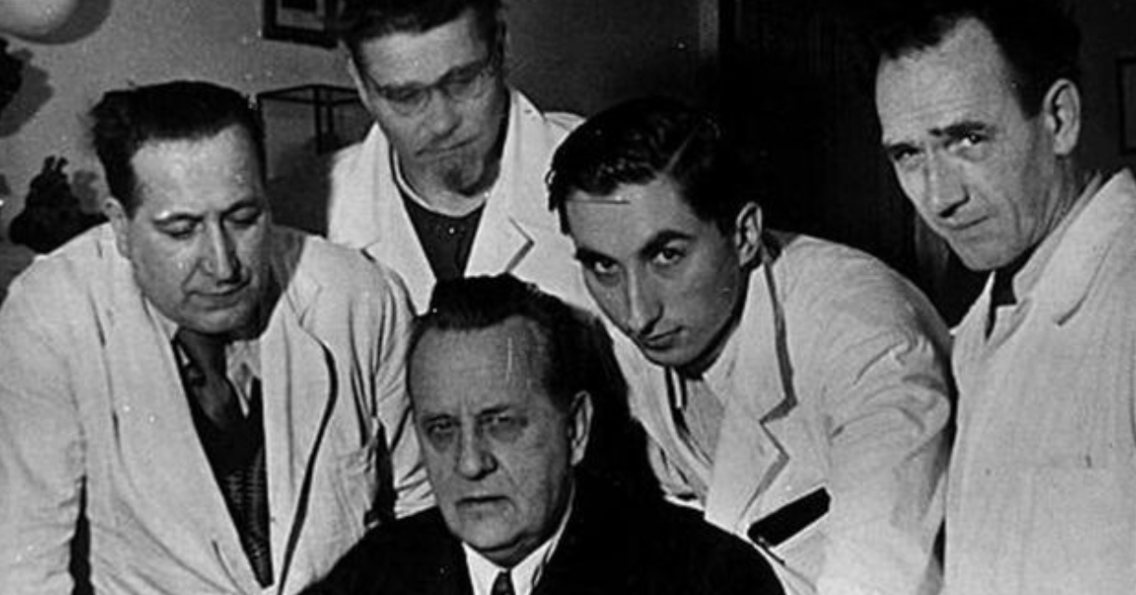

Pernkopf (seated) and four of his artists. From the left: Erich Leper, Ludwig Schrott, Karl and Franz Intresser Bathke. (BBC.com)

Paterniti (2002) describes David Williams’ visit to the repository in which the paintings used for the atlas are stored. Werner Platzer, who completed the last two volumes, showed Williams the nineteen binders stuffed with 800 original works of art.

‘He asks Platzer why he thinks the book is out of print, and Platzer shakes his head, incensed. “It's too good,” he says. “The Book is too good.” When Williams points to a painting that many feel is that of a Jewish cadaver with a shaved head, Platzer explodes. “What does a Jew look like?” he says. “Tell me. It is absurd. I wish you Americans ate what we ate then: nothing. Three days a week, I might not eat. I looked like this man here. Absolute nonsense.” The viewing takes seven hours, and in the end he feels it all over and over: joy, curiosity, shame, awe. In person, in full color, the paintings still shimmer and mesmerize. They still emanate.

‘But this time in their presence, he is not exactly euphoric. If he feels a deep sense of fulfillment in seeing these paintings one last time, he also feels a strange sadness. When it is over, when the sun dips below a building and a streetlight blinks on in the window, he is almost trembling. He pulls out a handkerchief, removes his glasses and wipes his face. His hair is slightly disheveled. He exhales, looks once at the oversize binders against the wall, presses his lips tightly together and then turns his back and leaves the room.’

It is also important to remain within the bounds of reason. What is one to make of the controversy regarding the United States National Library of Medicine’s Visible Human Project? The person who became the male Visible Human was Joseph Paul Jernigan. Jernigan was a convicted murderer. On July 3, 1981, he stabbed and shot to death a seventy-five-year-old man, who surprised him during a robbery. He was executed on August 5, 1993. He had willed his body to the Texas Anatomy Board, but almost certainly did not know he was a candidate for the Visible Human Project at the time of his death. Only after the body had been selected and processed did the committee choosing the body realize that they had selected an executed prisoner convicted of murder. The use of this particular cadaver raises the question of whether the project glamorizes a convicted murderer, making him appear more sympathetic by allowing him to perform a service to society through no effort of his own. The *Visible Human Male* is, after all, a rather heroic, perhaps even a noble figure. Neither the National Library of Medicine nor the Colorado team identified Jernigan as the Visible Human male. However, his date and cause of death, as well as his state of origin were public information. His identity has been widely known and reported.

This case also raises the issue of proper informed consent. The committee decided that because the man had freely donated his corpse to medical research, there were no ethical barriers to it becoming part of the project.

The announcement that the subject was an executed prisoner brought an interesting response from, of all places, the University of Vienna, specifically a group from the Department of Emergency Medicine. These doctors maintained that the death penalty and medical participation in an execution were unethical and that informed consent by the executed person did not dispel the unethical basis of the material used in this project. They called for the immediate withdrawal of the anatomical images as morally necessary. (Atlas 2001)

Summing up

Appleyard (2017), discussing the arts in general and writing on Christmas eve, posed the question: Should we love the art if the artist is a monster?

He came to certain conclusions. Good or great art may be made by people who have done something horribly wrong. He quoted Roger Crisp, professor of moral philosophy at Oxford. ‘…Imagine if more and more revelations came out, so almost every great artist was morally tainted. Would we stop looking at art? I don’t think so.’

Appleyard asked, ‘What about Caravaggio, a murderer, a street hoodlum and one of the greatest artists of the Renaissance?’ Waldemar Januszczak, art critic, felt that Caravaggio’s art ‘has such enormous power and depth, carries so much religious conviction, that the darkness of its creator feels irrelevant.’ Appleyard also reminds us of Paul Gauguin – ‘a paedophile racist, running around with these 13-year-old girls who become his so-called wives. Many scholars think it completely compromises you when you look at those doe-eyed, brown bodies and how they were representative of a culture of racism and colonialism.’ Tamar Garb, professor of the history of art at University College, London, commented that the history of art would have been different if there had been no Gauguin just as the history of cinema would have been different without Roman Polanski.

Perhaps we should follow the principle used by Roland Barthes, ‘the most influential aesthetic thinker of the 1970s. For him, once a work of art is made, the creator vanishes, becoming an irrelevance.’

The controversy over Pernkopf’s atlas has resulted in some good. It provoked a historical and ethical analysis of the study and teaching of anatomy in Austria and Germany during the Nazi era and prompted philosophical debate as well. Hildebrandt (2006) discusses these aspects and points out that in the case of this atlas the dilemma was especially poignant as the volumes under discussion provided unparalleled anatomical illustrations that remain useful to surgeons and students alike. She refers to the more recent criticisms of another German anatomist, who had once served on the faculty of the University of Heidelberg – Gunther von Hagens, who has been accused of using bodies of executed criminals from China. (Harding 2004)

Hildebrandt’s conclusions (2006) are rational and thought-provoking. Pernkopf’s atlas is the ‘product of the very human mind of an obsessive perfectionist who would have pursued his work under any political circumstances. Indeed, the first and the last parts of the atlas were not created during the time of the NS regime in Austria but before and after under very different political and material conditions… a ban could not atone the great evil committed by human beings on other human beings. Rather, it is up to a new human generation to glean good from this murky history by continuing to use Pernkopf’s atlas in a rational, historically conscious manner.’ As she points out, the atlas can be used to teach not only anatomy but also history and ethics.

Yee and co-workers (2018) discussed the continued use of the atlas with historians and religious authorities. Rabbi Joseph Polak, a Holocaust survivor and Chief Justice of the Massachusetts Rabbinical Court was one of the experts consulted. The general conclusions were that the use of the atlas could be permitted under the Jewish principle of *Pikuach Nefesh* – the saving of human life. (For greater detail, see Polak 2017.)

I found the statements made by Dr. Susan Mackinnon, who continues to use the atlas when performing complex operations on nerves, relevant: ‘I would think that as an ethical surgeon I would take it as a given that I should use whatever educational resource I thought would help me to maximise a successful outcome and that my patient would expect that of me. In my experience, it would set back detailed nerve surgery tremendously if these books are lost.’ (Baker 2019)

Conclusion

When scientific data is obtained unethically, the means can only be condemned. There can never be a justification for such practices as were used by the Nazi medical experimenters that violated all ethical principles.

That said, what is to be done to the invaluable, life-saving data yielded by such unethical studies? The victims of unethical practices have already passed away. We do them no harm by using the data.

We have two options. Erase all such data from all our medical repositories in such a manner that they can never be used by anyone. We shall then have jettisoned life-saving information and practices. This step may result in the worsening of patients who could have been helped by such information or even result in the loss of their lives. How does this help humanity?

The second option is to use the life-saving data and practices whilst remaining fully aware of the means by which they were obtained. In teaching institutes in particular, whenever such data is used to help the patient, a tribute is paid to the victims from whom this beneficial information had been obtained. This will also impress ethical principles upon young minds.

In making such use, we are remembering and honouring the victims even as we ameliorate symptoms and save lives.

References

Appleyard Bryan: Should we love the art if the artist is a monster? *The Sunday Times* 24 December 2017

Atlas Michael C: Ethics and access to teaching materials in the medical library: the case of the Pernkopf atlas. *Bulletin of the Medical Librarians Association* 2001;89:51-58

# Bagatur Erdem: Nazi medicine – part 2: the downfall of a profession and Pernkopf’s anatomy atlas. *Clinical Orthopaedics and Related Research* 2018;476:2123-2127

Baker Keiligh: Eduard Pernkopf: the Nazi book of anatomy still used by surgeons. 19 August 2019. Accessed from <https://www.bbc.com/news/health-49294861> on 31 May 2020.

# Bruns Florian, Chelouche Tessa: Lectures on inhumanity: teaching medical ethics in German medical schools under Nazism. *Annals of Internal Medicine* 2017;166: 591-595.

Buklijas Tatjana: Culture of death and politics of corpse supply: anatomy in Vienna. *Bulletin of the History of Medicine* 2008;82:570-607

Czech Herwig: Hans Asperger, national socialism and ‘race hygiene’ in Nazi-era Vienna. *Molecular Autism* 2018;9:1-43

Harding Luke: Von Hagens forced to return controversial corpses to China. *The Guardian* 23 January 2004

Hildebrandt Sabine: How the Pernkopf controvers facilitated a historical and ethical anaylsis of the anatomical sciences in Austria and Germany: a recommendation for the continued use of the Pernkopf atlas. *Clinical Anatomy* 2006;19:91-100

Hubbard Chris: Eduard Pernkopf’s *Atlas of Topographical and Applied Human Anatomy* the continuing ethical controversy*.* *The Anatomical Record (New Anat)* 2001;265:207-211

Israel Howard A: The Nazi origins of Eduard Pernkopf’s *Topographische Anatomie des Menschen*: the biomedical ethical issues. *Reference Librarian* 1998;61/62:131–46.

Kershner Isabel: In Israel, modern medicome grapples with ghosts of the Third Reich. *The New York Times* 12 May 2020.

Norton Scott A: On first looking into Pernkopf’s atlas. (Part 1). *Archives of Dermatology* 2001a:137:549-551

Norton Scott A: On first looking into Pernkopf’s atlas. (Part 2). *Archives of Dermatology* 2001b:137:867-868

Paterniti Michael: The most dangerous beauty. *GQ* 28 September 2002 <https://www.gq.com/story/pernkopfs-anatomy-nazi-history> Accessed on 18 April 2020.

Pernkopf Eduard: *Atlas of topographical and applied human anatomy*. Edited by: Helmut Ferner. Translated from the German by Harry Monsen. Volume 1. Head and neck. 2nd revised edition. Baltimore-Munich: Urban & Schwarzenberg. 1980

Polak Rabbi Joseph A: ‘*Vienna protocol’ for when Jewish or possibly-Jewish human remains are discovered.* Editors: William Seidelman, Lika Elbaum, Sabine Hildebrandt. 22 November 2017. Available at the web site of the Elie Weisel Center for Jewish Studies. <http://www.bu.edu/jewishstudies/research/medicine-and-the-holocaust/recommendations-for-the-discovery-of-jewish-remains-project/>. Accessed on 14 April 2020.

Pringle Heather: Confronting Anatomy’s Nazi past. *Science* 2010;329:274-276

Riggs G. What should we do about Eduard Pernkopf’s atlas? Academic Medicine 1998;73:380–6.

Silver J R: The decline of German medicine 1933-1945. *Journal of the Royal College of Physicians of Edinburgh* 2003;33:54-66

### Vollmann J, Winau R: Informed consent in human experimentation before the Nuremberg code. *BMJ* 1996;313:1445-1447

Weindling Paul: Human guinea pigs and the ethics of experimentation: the *BMJ* correspondent at the Nuremberg medical trial. *BMJ* 1996;313:1467-1470

Yee Andrew, Hildebrandt Sabine, Seidelman William E, Mackinnon Susan E: Letter to the editor: Nazi medicine – Part 2: The downfall of a profession and Pernkopf’s anatomy atlas. *Clinical Orthopaedics and Related Research* 2018;476:2465-2466

Yasargil M Gazi: Impact of temporal lobe surgery. (Editorial). *Journal of Neurosurgery* 2004;101:725-738

Yee Andrew, Coombs Demetrius M, Hildebrandt Sabine, Seidelman William E, Coert J Henk, Mackinnon Susan E: Nerve surgeons’ assessment of the role of Eduard Pernkopf’s Atlas of topographic and applied human anatomy in surgical practice. *Neursurgery* 2019;84:491-498

1. Department of Neurosurgery, Jaslok Hospital & Medical Centre, Dr. G. V. Deshmukh Marg, Mumbai 400026. Email: [shunil3@gmail.com](mailto:shunil3@gmail.com)